Website Specifications

Website Name: BMW M Series Website
Brand: BMW

Purpose
The reason behind this website being made is to showcase performance vehicles made by Bayerische Motoren Werke formally known as BMW. The section the website works on is the motorsport or the M series, which is the performance part of BMW such as BMW M4 etc. The website provides information about their Motorsport cars or M series in short, information such as their specifications, history and design. The website is made to inform users about the performance side of BMW and to promote their cars.

Goals
- Educate users about BMW M series cars
- Provide correct specifications of the cars
- Direct users to the official BMW pages
- Make the website have the same aesthetic as the BMW website

Target Audience
- Age: 18 – 50
- Interests: High performance cars, luxury vehicles
- Technical Level: Basic to intermediate internet users
- Devices: Mobile phones, laptops and tablets

Website Type
- Informational and product showcase website

Information Design and Taxonomy

Site Map
WireFrame

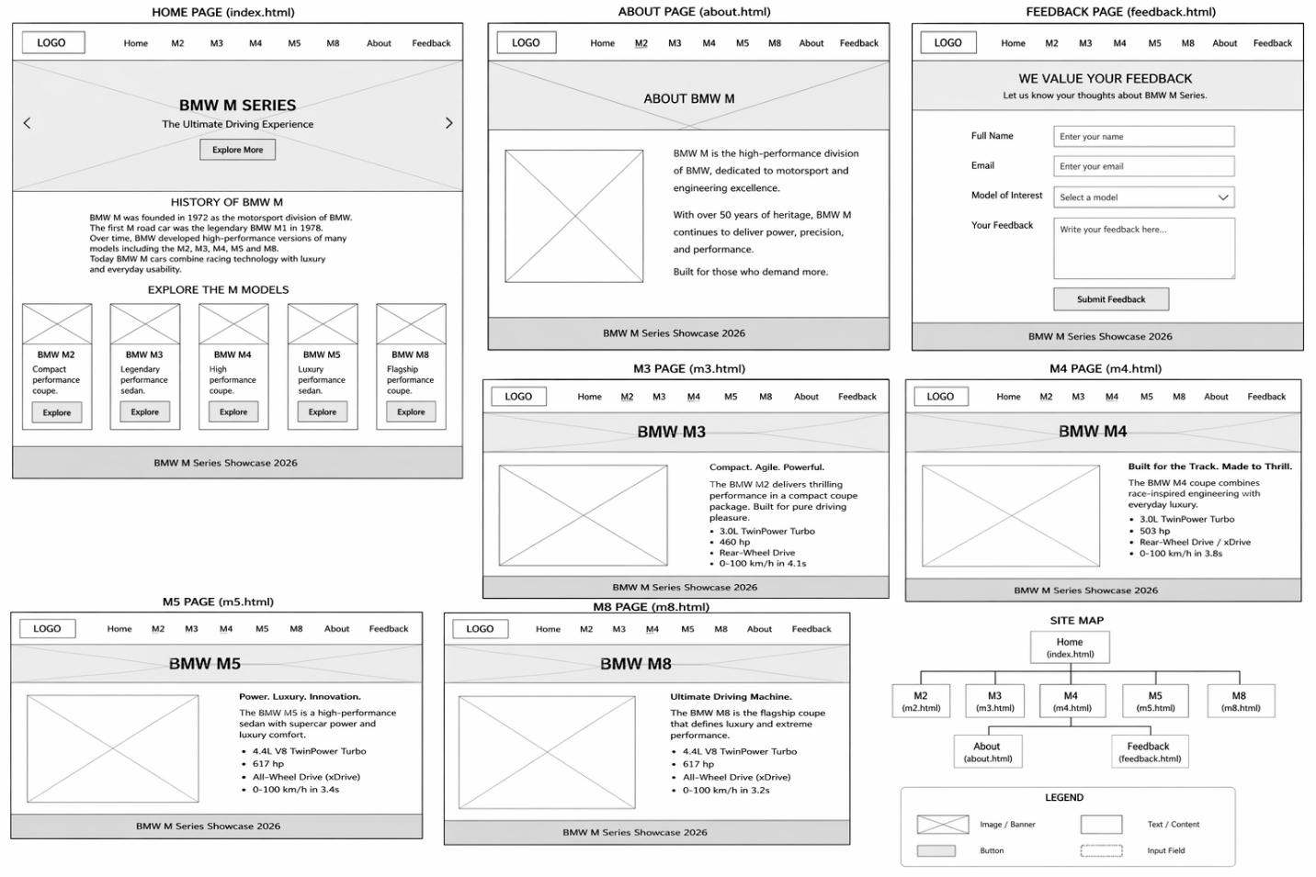

Plain text

Home (Index.html) |
|---M2 Page (m2.html)
|---M3 Page (m3.html)
|---M4 Page (m4.html)
|---M5 Page (m5.html)
|---M8 Page (m8.html)
|
|---Feedback Page (feedback.html) to be added in the next update
|
|---About Page (about.html)

Navigation Flow
- Users land on homepage
- They click on any car, they are then sent to the car page
- Each page has a link back to home
- About page explains the website
- The feedback page is to be implemented in the next update

- The page follows the 3-click rule

Page Template Design

Layout Structure
- Header (Logo and Navigation)
- Hero Section (Car Image and Title)
- Content Section (Specs and History)
- Gallery Section (Images)
- Footer

Technical Brief
Technologies used:
- HTML5 -structure of pages
- CSS3-styling and layout
- JavaScript-animations and interactivity
- VS Code- coding editor
- GitHub-version control
- GitHub Pages-hosting
Resources
- BMW M series car pictures from the internet
- BMW Official website links

Quality Assurance

Tests Performed
Browser Testing
- Mozilla Firefox
- Google Chrome
- Safari
- Microsoft Edge
Mobile Testing
- Tested using Chrome mobile view
- Responsive layout works properly
Link Testing
- All links work perfectly
- There are no broken links

Publishing and Promotion

Hosting Method
The website is hosted using GitHub. The files were uploaded manually because the git commands are not working so the codes were uploaded manually.

Future Improvements
- Adding car comparison features
- Add search functionality
- Add animations like the original BMW website
- Add dark and light mode

